|  |  |
| --- | --- |
| A picture of a winding road and trees  USER GUIDE OF MemorizeYC  (Web version)  v2016.823.8 | Introduction  The main purpose of this program is to help people to imprint the stuffs that they want to remember efficiently by the help of the Ebbinghaus forgetting curve and interaction in their mind. In this user guide, you will see how this APP interacting with the user and remind the user to replay again by the concept of forgetting curve. However, because most browsers cannot access the files in users device, this web version cannot use the data made by users themselves as the material for their own study just as its windows App can do.  Young-Chung Hsue |
|  |  |

Contents

I. Look: 3

A. Main menu: 3

B. Play Page: 4

1. Hint mode: 5

2. Pair mode: 6

3. KeyIn mode: 7

4. Interactive tutorial: 8

5. Ending: 9

II. Getting Started: 10

A. Where to start? 10

B. The first experience: 10

1. Pair mode: 10

2. Hint mode: 11

3. Back to main menu: 11

III. Description of each part: 12

A. Main menu： 12

1. Container: 12

2. Category: 12

3. Play button: 12

4. Resize button for the realm of containers: 12

5. Text language button: 13

B. Play Page: 13

1. Cards: 13

2. Speech language dropdown： 14

3. Dropdown of settings: 15

4. Hint mode: 17

5. Pair mode: 18

6. Key In correct answer mode: 19

IV. For instructors and self-learning: 21

A. Why? 21

B. Design: 21

C. Collecting data: 22

D. Put those data on the Web: 23

E. Afterword: 24

# Look:

## Main menu:

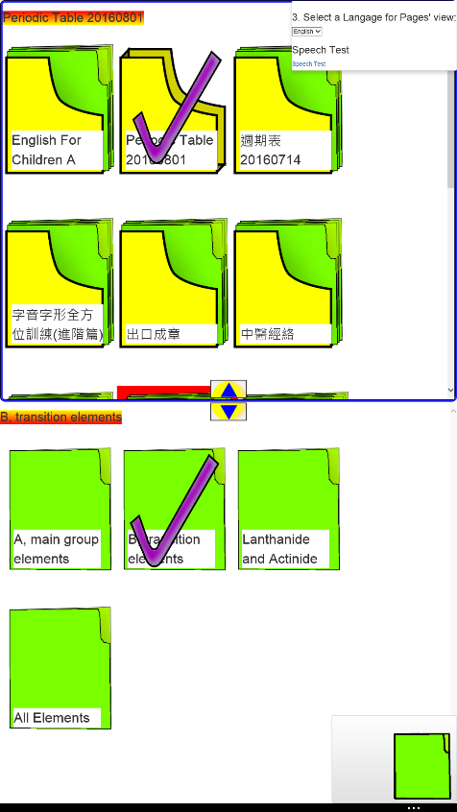

Select a language for texts

Name of selected container

Speech test

Selected container

Resize the room for containers

Name of selected category

Selected category

Clicking it to play

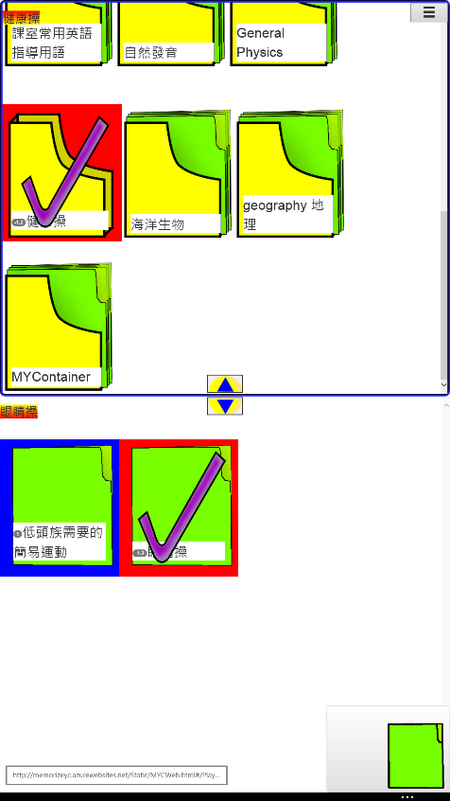

An out of date, selected container

A container never be played

A selected, expired category

Undue category

## Play Page:

Click button -> Dropdown for settings

Set ***n*** and show next new ***n*** cards (randomly)

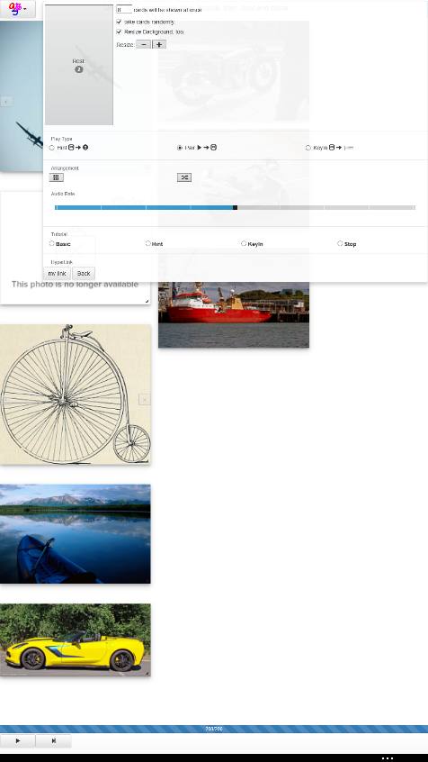

Click once means select; click twice means showing more information. By the way, if you have a mouse, you can resize and move all the cards.

Name of this category

Current score. Count invertedly.

Switch the content of a card if it contains more than one cards.

Back MemorizeYC’s main page

Select a speech language

Link or back to previous page

4 kinds of interactive tutorial

The ratio of speech synthesis

Arrange cards (randomly)

Three game modes

Change all cards’ (background) size

Click button -> Dropdown for speech

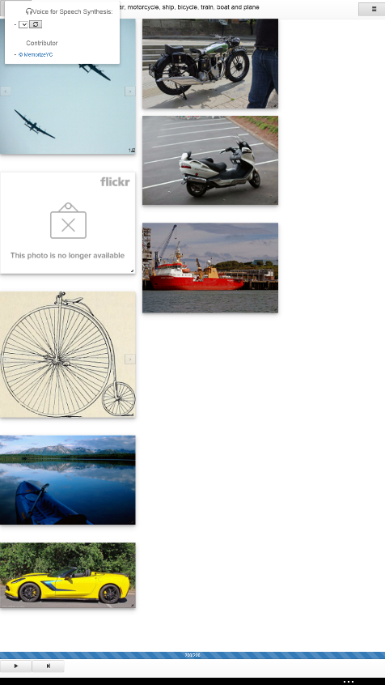

### Hint mode:

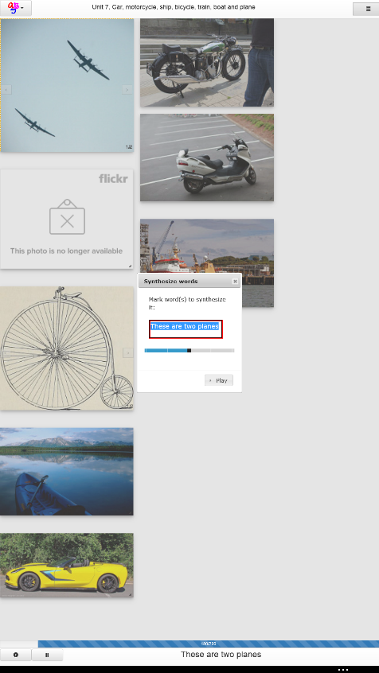

Pause if it is dictating in succession.

Dictating answer of cards in succession.

Dictate the selected texts.

Speech ratio

Editable texts. By default, it is the answer of the selected card.

This textbox will show the answer of selected card. Besides, a single click upon it will show a popup above.

Selected card by clicking it once will blink.

### Pair mode:

Please click Play() or Next() button to start the game.

Single tap. It will be annihilated if it matches the answer; otherwise, it’ll shake.

Change to next answer

Dictate the answer again

Editable texts. By default, it is the answer of the selected card.

This textbox will show the answer of selected card. Besides, a single click upon it will show a popup above.

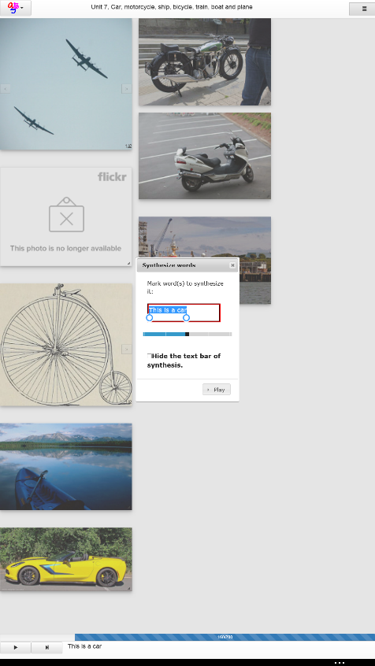

Hidden the textblock at the bottom.

Speech ratio

Dictate the selected texts.

### KeyIn mode:

Selected a card at first, then you need to input its answer into the bottom textbox.

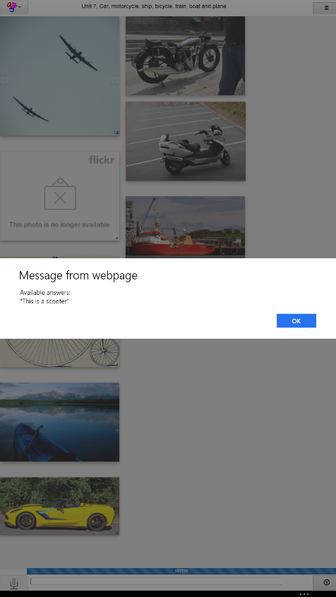

All sentences blocked by “” are available answers. In this case, it has one available answer: This is a scooter.

Input from microphone if it can be

Key in the correct answer

Submit the answer

A hyperlink concerned with this card.

Show available answers, but it will cost you some scores.

The extra description of the selected card.

One tap means select it; two taps will show a popup with its extra information.

### Interactive tutorial:

This interactive tutorial runs with the game modes. It will guide you how to have a better user experience in each mode. Every time you need its help, you just need to tap the settings button on the top-right corner and select a mode you want to learn in the list of tutorial mode.

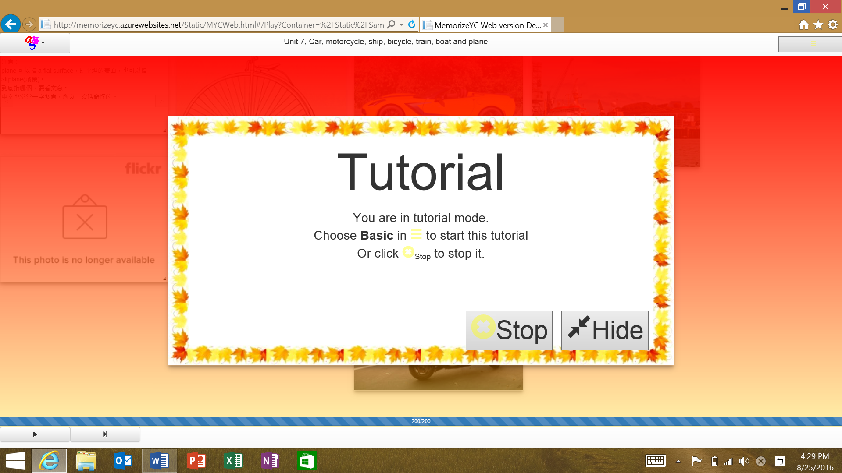

Stop the interactive tutorial

Hide this popup; however, it does not mean that you stop it, you just hide it because you might want to tap one or some cards covered by it.

### Ending:

Play it again now

Finish this study (Play)

Score/Full mark

The level you really can pass

Current Level for forgetting curve

# Getting Started:

## Where to start?

<http://memorizeyc.azurewebsites.net/Static/> is the address of this Web version, or you can get into this web application by clicking the red button in <http://memorizeyc.azurewebsites.net/>.

Once you get into this Web application, the first page you see is the main page. Choose one container and click it, such as ‘periodic table’, its contained 4 categories will show up. Then, click one category such as ‘B, transition elements’, a button will appear at the bottom-right corner of your browser. Once you click that button, you will have your first play!

## The first experience:

When you first time get into this page, it will show you a popup with background of red and yellow and it means that you are in tutorial + pair mode. Follow its suggestions and accomplish them one by one, you will get a mental picture of this application. However, now clicking the X(Stop) to leave this tutorial mode since you are following this tutorial. Do not worry. You still can get into this tutorial mode in the future by selecting a suitable topic in the tutorial list.

### Pair mode:

Because the level is start from 0, it will be in pair mode by default. Please clicking  or  at first. If your speaker is not muted, your browser (such as Edge, Chrome, Safari, etc.) support speech synthesis, and the speech language selected from the selection box in the dropdown shown by clicking the top-left corner button is correct, it will select one card, show its answer in the bottom textblock and dictate its answer. However, if the texts are Chinese texts but the speech language is English, nothing can be heard.

After the dictating, you can click a card, which is the right one you think. If the card you clicked is the right one, it will be annihilated; otherwise, it will shake to let you know that you choose a wrong one. When all the cards are annihilated, it will show up a popup to tell you about your score, your level for forgetting curve and your real level enclosed by ‘()’. Clicking [OK] to finish this study + play.

### Hint mode:

Well, in some occasion such as the selected container is the periodic table, you might not know them clearly, the pair game become a terrible, frustrate, and boring game. If so, please switch the mode to Hint mode at first.

If I know nothing definitely about this category, I will click the left-bottom button  to let it dictate all the cards in succession. If you want to suspend the dictating, you can click the button  to pause the dictating. If you just want to know the answer of a specific card, just clicking it is enough. It will dictate the answer of that card. How many times you tap it, how many times it dictate its answers for you. If possible, I hope that you can dictate the sentence with it to enhance your memory.

Once you get a clearer concept about them, you can play it with more comfortable after switching back to pair mode again.

### Back to main menu:

Once you finish a study of a category and go back to the main menu, you will find that the main menu is slightly different as shown in the second picture of the main menu of the Look. You can find that the background of the category you just played becomes blue and there is a number ‘1.0’ behind its name.

The color blue means that it is undue and the number inside is the rest dates. Therefore, ‘1.0’ means that the due date is at one day later.

Otherwise, you can find that there is one red container, and it has two categories, one is red, the other is blue. The red ones mean that they are over the due date so that their number become negative; the smallest number of its categories decides the number and color of a container.

Based on the colors and the numbers of containers and categories, you can clearly see which one is over the due date and need you to replay it again. By this way, we can let it to help us to review the stuffs based on the concept of forgetting curve.

# Description of each part:

## Main menu：

### Container:

The difference between them are whether the user played them. If the user ever played them, its background will be red or blue and there will be a number before its name. The number indicates how many days before the due date so that a negative number means it is out of date. Besides, undue and overdue relate to the blue and red color, respectively. By the way, a container’s number is the smallest number of its categories; therefore, if one of its category is overdue, this container is overdue, too.

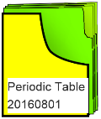 or 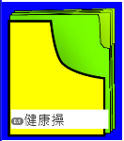.

### Category:

Their basic rule is the same as containers’. By the way, there will be a check mark upon a container or a category when the user select them.

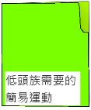 or .

### Play button:

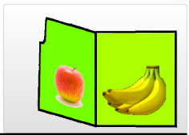 As long as you select a container and a category, this button will appear at the bottom-right corner of your browser’s window. Once you click it, you will start your study of this category.

### Resize button for the realm of containers:

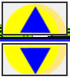Because the realm of containers might be too small or too large for the user, the user can change its size so that the user can see the whole list of containers or categories.

### Text language button:

It is at top-right corner of your bowser’s window. Once you click it, a dropdown as shown in the right hand side will appear. Inside this dropdown, you can select your texts’ language. At this moment, it supposes Traditional Chinese and English. If you change it, you will see all the texts are changed immediately.

## Play Page:

### Cards:

#### Single click each card:

Although the main meaning of a single click is SELECTING THAT CARD, its meaning will be a little different in Hint, Pair and KeyIn modes. I want to discuss them later.

#### Double click each card:

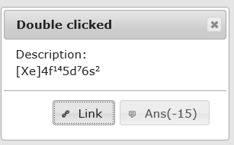 Double click each card means to show its extra information in a popup as shown in the right hand side picture. It consists of two main parts: the first one is a description for it, such as [Xe]4f… in this example; the second part is a hyperlink and both of these are provided by the instructor. Therefore, a card might not have them. In this picture, you can see that there is an extra button, which will show up when the user is in KeyIn mode. Once the user click this button, it will show the user the acceptable answers; however, once the user click it, he/she need to pay 15 points for this action since he/she is playing. 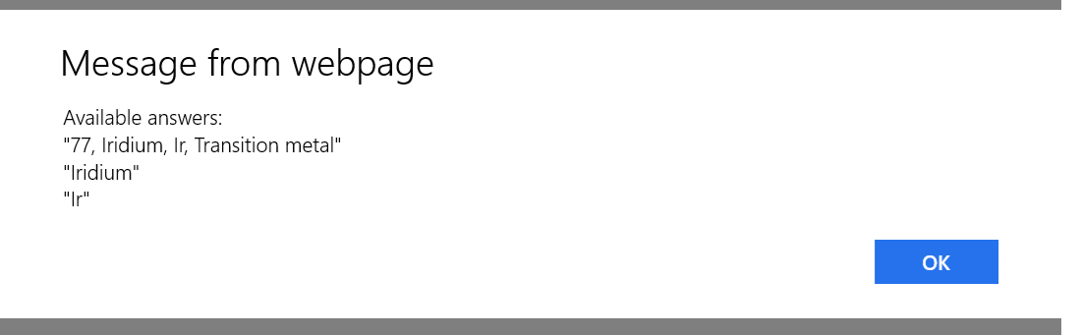In the above example, you can see that ”77, Iridium, Ir, Transition metal”, “Iridium” or ”Ir” are all the correct answers for the chemical element 77.

### C:\Users\Young-Chung\AppData\Local\Microsoft\Windows\INetCache\Content.Word\dropdownOfSpeech.pngSpeech language dropdown：

Once you this button at the top-left corner of your browser’s window, a dropdown will show up as the picture in the right hand side. The browser of this example is Microsoft Edge (Windows 10) and you need to install your desire speech languages through the action center at the bottom-right of the desktop of your Windows 10. In the action center -> all settings -> time and language -> region and language, you can install the language you want. If you are using Chrome, the speech service is gotten from the web server, nothing you need to do, it will has a list of languages for you; by the way, Safari has installed a lot of languages for it, you don’t need to install them, too. However, it names those languages by the owners of them so that it is hard to guess which language it is related to. Well, you can find it out from the BCP47 code inside the parenthesis ‘()’, you can search that BCP47 code directly on line. By the way, Safari cannot catch its voice list sometime but the speech synthesis is still work. Therefore, even if it shows you a blank list, you still can hear the dictating in Safari.

Theoretically, if this list is not blank, the speech synthesis should works. However, if you hear nothing but it should dictate, the possible problems are:

1. You select a wrong speech language, you need to change it to the correct one such as that you cannot dictate Chinese words when its speech language is English.

2. A mobile device usually has more than one volume control, you might have maximize the volume of ring; however, the volume of Media or APP is 0 so that no dictating can be heard. You need to check them because most of problem is related to this one.

3. Your spear is setting off in your device.

Since your device has the ability for speech, let it work and enjoy it! Learning something by hearing can enhance the learning efficiency.

### Dropdown of settings:

Once you press this button at the top-right corner of your browser’s window, a dropdown will appear. It consists of seven main parts and each part has their own purpose described below:

#### Decide showing which cards:

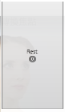 and

Click the button will change cards. The number inside the input box and the number inside the button are of how many cards will be shown at once and of the rest cards, respectively; therefore, if the number of rest card is not zero, the sum of these two number is the total number of cards this category has. By the way, you can change cards randomly if the check box is checked.

#### Resize Cards and the background:

Press + or – sign will resize all the cards. Besides, some categories has a background. If you also want to resize its background, you should check the check box.

#### Select a Game mode:



They are Hint mode, Pair mode and KeyIn mode, respectively. By default, it will be in the Pair mode. However, for a user from out of any concept to familiar with it the learning sequence should be Hint -> Pair -> KeyIn, I do not set the Pair mode as the first one. I think that keeping this learning sequence is clearer.

#### Arrange cards:

Left hand side button is to align the cards, but the right hand side button will rearrange the cards randomly.

#### Tune the speech ratio:

 The speech ratio is set as 2n ;therefore, the highest and the lowest are 4 and 0.25, respectively. Because the middle value of this range bar is 0, the speech ratio will be 1(20). I usually use this range bar to slow down the speech since I want to hear some words in a slower pace.

#### Interactive tutorial:

It has four options. Once you tap one of them, a tutorial popup will appear and you are in interactive mode immediately. These options are Basic, Hint, KeyIn and Stop. It might be strange for you that why I need a stop option. The reason is since it is an interactive tutorial, it will not change to next action until the user accomplish the required action and a concept might consist of many actions, the user may not want to undergo all the actions. If so, the user need this stop option to leave the interactive mode.

#### Hyperlink:

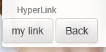At this moment, there are only two buttons. The first one is provided by the instructor for this category, and you can go back to previous page by clicking the second button. What this ‘Back’ button does is similar to what pressing ALT+left arrow keys or pressing Back button of your browser do.

### Hint mode:



Once you setting your game mode to be Hint mode through Game mode setting, the toolbar at the bottom will change to the one as above shown. From this picture you can find that the user has already pay 20 points when he/she get into this mode. Don’t worry, all the other actions inside this mode will cost nothing. Why do I want the user to pay 20 points, a card’s point, when he/she get into this mode? If not, some cunny users might do trick to this application such as copy and paste. No, it will be not fair if they are in a competition.

This toolbar consists of three parts: selecting cards in succession, pausing the behavior of selecting cards in succession and showing selected card’s answer in this textblock.

#### Selecting cards in succession:

Once you press this button, it will select the card that is selected previously and dictate that card’s answer. After the dictating is done, it will select the next card and dictate that card’s answer until the final card. How about the case that the user select nothing before he/she click this button? Well, its selection will be from the 1st one to the last one.

#### Pausing the behavior of selecting cards in succession:

Tap this button to pause the behavior of selecting cards in succession. Although you can select a card by tapping it, tapping a card will not stop the behavior of selecting cards in succession.

#### Text block of Answer:

This text block show the answer of the selected card. If you click this text block once, a popup as shown in the right hand side will appear. In this popup, clicking the **Play** button will dictate the words selected in the text box above it with the speech ratio determined by the range bar. For example, it will dictate the 19th element of periodic table as “19, Potassium, K, alkali metal”. However, for a foreigner as me, I just want to be familiar with the pronunciation of “Potassium”. In this case, I can achieve this goal by selecting just the word “Potassium” and then tapping the “Play” button to dictate this word only.

#### Single click a card:

The meaning of clicking a card means to select that card. The selected card’s border will blink. If Speech synthesis is available on your browser, it will dictate the selected card’s answer.

#### Double click a card:

It will show you the extra information of the double clicked card. To see more details, please the discussion in Play Page -> Cards -> Double click each card .

### Pair mode:



Once you setting your game mode to be Pair mode through Game mode setting, the toolbar at the bottom will change to the one as shown above. It works as someone dictates one card’s answer and you need to find out the matched card. From this picture you can find that the user has already pay a little points. The reason is that I have started the pair mode game. Once you start the game, you need to pay one point per second. If the card you tapped does not match the answer, you should pay a little extra points. Don’t worry, the highest payment for each card is 20 points. If you exceed this limit, you don’t need to pay more points for that answer.

This toolbar consists of three parts. They are dictating current answer, dictating next answer and a text block.

**Note: Clicking or  to start this Pair mode. Nothing will happen when you click a card at first.**

#### Dictating current answer:

If speech synthesis is available for your browser, you can force it to dictate the answer again by tapping this button.

#### Dictating next answer:

It will select next answer for matching card. If speech synthesis is available for your browser, it will dictate the new answer, i.e. you need to find another card to match this answer.

#### Hiding the text block:

Why do we want to hide the text block, i.e. you don’t want to see the answer? The reason is that sometimes I want the students can try to find the matched card based on their hearing. If so, the answer shown in the text block will usurp the students’ attention. Because of this, I want to hide it. How to hide it? You can hide it by checking the check box in the popup shown in right hand and this popup is launched by single click the text block of the answer. By the way, it still has some other functionality as the one discussed in Hint mode -> Double click a card.

### Key In correct answer mode:



As long as your level is higher than five, or changing the mode to this one through Game mode setting, the toolbar at the bottom will change to the one as shown above. As you can see, no point you need to pay when you get into this mode.  **When you are in Pair mode, you need to tap the buttons in the bottom toolbar first, and then you need to tap the correct card to annihilate that card. However, you need to tap a card first in this KeyIn mode to select it, and then you need to input the correct answer into the text box to annihilate the related card. How to submit your answer? By pressing Enter key or by tappingyou can submit your answer, if your answer is correct, the card will be annihilated.**

This toolbar consists of three parts. They are input from microphone, input from text box and the submit button.

#### Input from microphone:

At this moment, only Chrome and Android’s browser support it. By default, your voice will be translated into a sentence and input into the text box. However, I still not find a good way to let the result of its recognition to be the same as the answer. By the way, if the action of recognition is not stop automatically, you should tap this button again to stop it.

#### Input from text box:

If your input is the correct answer, the selected card will be annihilated. Here comes two questions. 1. How to submit your answer? 2. What is the acceptable answer? The answer of the first question is that you can input your answer into the text box and then press the Enter key, or tap the submission button to submit your answer. The answer of the second question is that you can get the available answers by clicking ‘Ans(-15)’ button in the popup of Play Page -> Cards -> Double click each card. By the way, the available answers are provided by the instructor.

#### Submission button:

Once you tap this button, texts inside the text box will be submitted. If it is the same as one of the available answer of the selected card, that card will be annihilated; otherwise, you will need to pay some points. No matter your answer is correct or not, it will dictate its answer again because my main purpose is imprint the knowledge into users mind, since it can dictate, why not let users can have an extra chance to enhance their memorization.

# For instructors and self-learning:

## Why?

Imaging that you are a parent of a kindergarten kid and you want to teach your kid about alphabet. If I were you, I would write each single letter on each individual card. Furthermore, just a letter might be too boring, I may decorate it with some graphs such an apple for the letter A.

At the beginning, I will show my kid the cards one by one with dictating. If possible, I’ll ask him to read it out, too. Next step, I may spread the cards on the ground and ask my kid to find out the correct letter that I dictate. During this process, I will encourage him continually; if his answer is correct, I might give him/her a small gift such as a candy. Once he/she gets the correct card, I’ll ask him to dictate with me again to enhance his/her memorization. Since my kid will keep growing, paying a little time to play with him/her every day is enough. Once it looks like that he/she has known almost all the letters, I may take one card and ask him/her how to dictate the selected letter. If possible, ask him/her to try to write that letter down. If he/she can, I think that he/she has remembered the alphabet and then we just need to help him/her to review them regularly.

However, during this process, you may encounter some difficulties. For example, it is not so easy for you to have a free time, once you have a free time after hard work and you want to play with your kid, he/she might not want to play with you at that moment. Or, although you have collect all the cards in a folder, you find that some cards are disappeared or even the folder has gone, oh man. Or, you are excited at the beginning, but a feeling of frustration appears because you do not play with your kid regularly; sometimes you might think that it is useless because you have left it for a long time. Finally, never play it again… Sadly, right?

## Design:

Basically, the designation of [MemorizeYC](http://memorizeyc.azurewebsites.net/) is based on the concept described above. I hope that I can make a simple platform for instructors and students; at that platform, the cards collected by the instructor or even the students themselves can easily become a game as I describe above. The demo of the example of the alphabet learning is located at one of the container  in <http://memorizeyc.azurewebsites.net/Static/>. There are some reasons make it better than real paper cards.

1. Once you create those cards, they can be shared for every one through network since they are just graph or text files so that you don’t need to worry about the possibility of losing them.
2. Thanks to people’s effort on the technology of Speech, only if the instructor is not comfortable to the speech synthesized by their device, he/she needs to record voices for the cards. In most case, the instructor can let the speech synthesizer to take over this job.
3. Since this application has consider the concept of forgetting curve to improve the learning efficiency, you don’t need to worry about how long that you have never reviewed because sometime we will feel that our study is vanity because we have been long long long time never touch it. Don’t worry, it will show you how much date you over the due date and you’ll find that it is not so long as we predict. For me I want to remember some stuffs for a long time efficiently, such as foreign words or chemical elements, etc. I’ll forget some of them after some time. I want to overcome this kind of feeling of frustration by forgetting curve. Then, I have more time to do other important things.

The current version of my Win APP is 7.0 and it works as the description above. By the way, one card can be a hyperlink of a text or image file and even contains more than one cards. For Web version, its version is 8.0, its card can be an animated gif file and the position of a card can be fixed such as the example in periodic table and geophysics. After finishing typing this document, I will try to embed these new functionality back to my Win APP.

By the way, this Web version is a javascript code running at client ,i.e. your device, side; therefore, most of data (through cache, localStorage and indexedDB) are getting from your device. It will not use your network resource too much although it need to get cards from web sites at the first time they are requested. By the way, this is an open source code whose license is MIT’s. You can get it source code from <http://github.com/ychsue/MemorizeYC.Web> freely. If you find it has any problem or has any suggestion, welcome you to [Email](mailto:hsuy1234@hotmail.com?subject=MemorizeYC.Web%20User%20need%20help.) me.

## Collecting data:

Suppose you are teaching Japanese language, you can create a new folder named Japanese Language as a container and a session folder as a category. Then, you just need to put some image or text files with file names as their answers into that category folder. Now it is enough for my Win APP. In fact, you even can create, edit or delete a card or fetch images’ link from Flickr and just link to those images.

However, you need some extra files for this Web version. Because of the security problem considered by the browser, the javascript code cannot access your local files, it is good but it means that the files should be on the server only. Besides, to protect the server, the client cannot know the folder and file structure of the server so that it needs some extra json files to describe those structure.

You should locate a description file MYContainer.json in each container and its JSON attributes are listed in [this link](https://github.com/ychsue/MemorizeYC.Web/blob/master/MemorizeYC.Web/Models/MYContainerJson.ts); and you should locate a description file MYCategory.json in each category and its JSON attributes are listed in [this link](https://github.com/ychsue/MemorizeYC.Web/blob/master/MemorizeYC.Web/Models/MYCategoryJson.ts).

To simplify the work of writing those json files, I wrote a simple PowerShell code in [this link](https://github.com/ychsue/MemorizeYC.Web/blob/master/ConfigureDescriptionFiles/Script.ps1). Before you use it, please change the parameters $rootDir and $TheContainer at row 5 & 6 to match your need and run it under Windows system. In the future, I want my Win APP can handle this job for users because it can do more than that PowerShell code.

## Put those data on the Web:

Why do I call this <http://memorizeyc.azurewebsites.net/Static/> as a demo web page? The reason is that what I hope the instructors can have a data which is organized by themselves. Although we can use the data made by someone else, I think that it will be funnier if the data is created by the students themselves. By the way, the teacher can also add some virtual treasures occasionally for students to find them out. For example, the instructor can add a new text card into one card said that the student who come to my office and pass a small test, he/she can get a small gift. I think it will make students feel funny and encourage them to review those categories often. For me, the common homework and tests in the traditional class is similar to the idea of forgetting curve. Since that, why not to make it funnier and let it be handled by their devices. I think that this APP can help them to do the personalization learning since everyone’s learning curve are different.

Therefore, if you are a teacher teaching in a school, you can show him/her this document and he/she can find how to embed this Web version into your schools server from [my github site](https://github.com/ychsue/MemorizeYC.Web). In its [README.md](https://github.com/ychsue/MemorizeYC.Web/blob/master/README.md) , it has told people how to embed it into their web server. Remember that, once you add a new container into your data server, you need to add **new AContainer(…)** into the array **GlobalVariables.containers** in your [index.html](https://github.com/ychsue/MemorizeYC.Web/blob/master/MemorizeYC.Web/index.html) file. If your school’s IT can help you to take over it, it will be simpler. If you need my help, please [Email](mailto:hsuy1234@hotmail.com?subject=MemorizeYC.Web%20使用者尋求幫助) me and I can give you a help.

## Afterword:

If I can, I want to let the instructor can create, delete, modify cards directly from the web site and it will be more convenient. However, the administration of accounts becomes a problem and it means that it is related to the server. Should I combine this part with some famous server style such as Moodle or photon? Or. should I write a server which is small but with complete function? I’m thinking about it. Anyway, hope this Web version is helpful for you and your students.